NAME:S.ROHINI
REG.NO:192424413
DATE:18-12-2025
DAY 3
LAB EXPERIMENTS
EXP.NO-11
Scenario : You are a data scientist working for a company that sells products online. You have been tasked with creating a simple plot to show the sales of a product over time.
Question:
1. Write code to create a simple line plot in Python using Matplotlib to predict sales happened in a month?
2. Write code to create a scatter plot in Python using Matplotlib to predict sales happened in a month?
3. Develop a Python program to create a bar plot of the monthly sales data.
CODE:
import pandas as pd
import matplotlib.pyplot as plt
import numpy as np
# Load dataset
data = pd.read_csv("big_monthly_sales_data.csv")
# Create month column (12 months from 365 days)
data["month"] = ((data["day"] - 1) // 30) + 1
# Aggregate monthly sales
monthly_sales = data.groupby("month")["sales"].sum()
# ---------- Line Plot ----------
plt.figure()
plt.plot(monthly_sales.index, monthly_sales.values)
plt.xlabel("Month")
plt.ylabel("Total Sales")
plt.title("Monthly Sales Line Plot")
plt.show()
# ---------- Scatter Plot ----------
plt.figure()
plt.scatter(monthly_sales.index, monthly_sales.values)
plt.xlabel("Month")
plt.ylabel("Total Sales")
plt.title("Monthly Sales Scatter Plot")
plt.show()
# ---------- Bar Plot ----------
plt.figure()
plt.bar(monthly_sales.index, monthly_sales.values)
plt.xlabel("Month")
plt.ylabel("Total Sales")
plt.title("Monthly Sales Bar Plot")
plt.show()
OUTPUT:
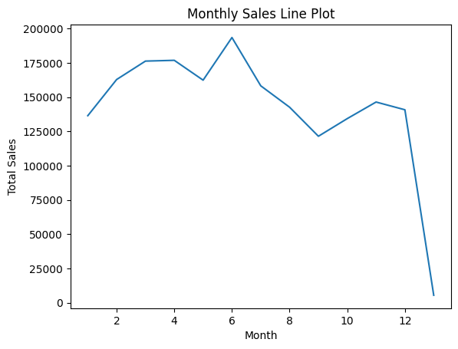
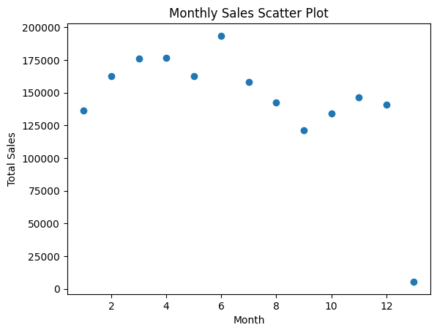
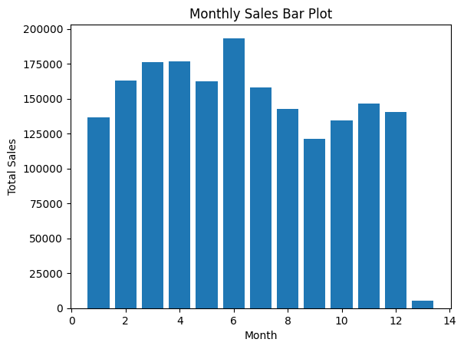
EXP.NO-12
Scenario: You are working on a data analysis project that involves analyzing the monthly temperature and rainfall data for a city. You have a dataset containing the monthly temperature and rainfall values for each month of a year. Your task is to develop a Python program that generates line plots and scatter plots to visualize the temperature and rainfall data.
Question:
- Develop a Python program to create a line plot of the monthly temperature data.
2: Develop a Python program to create a scatter plot of the monthly rainfall data.
CODE:
import pandas as pd
import matplotlib.pyplot as plt
data = pd.read_csv("weather_data.csv")
plt.plot(data["Month"], data["Temperature_C"])
plt.xlabel("Month")
plt.ylabel("Temperature (°C)")
plt.title("Monthly Temperature Variation")
plt.show()

import pandas as pd
import matplotlib.pyplot as plt
data = pd.read_csv("weather_data.csv")
plt.scatter(data["Month"], data["Rainfall_mm"])
plt.xlabel("Month")
plt.ylabel("Rainfall (mm)")
plt.title("Monthly Rainfall Distribution")
plt.show()
OUTPUT:
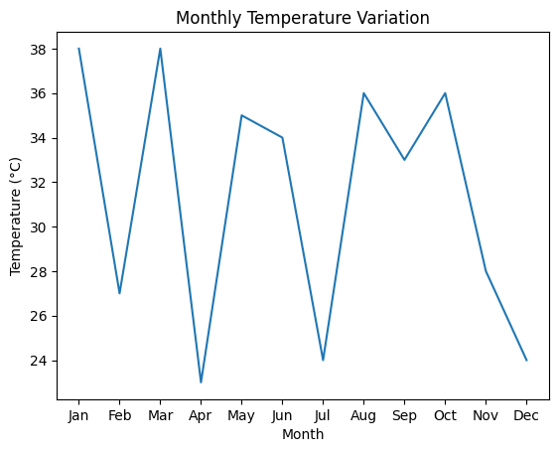
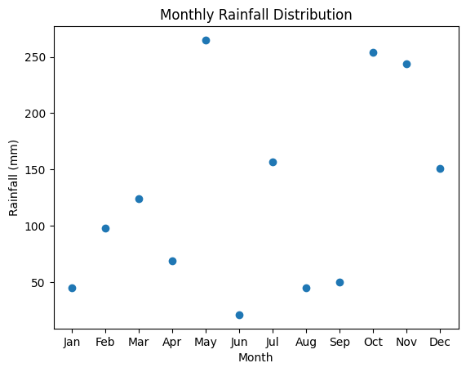

EXP.NO-13
Scenario: You are working on a text analysis project and need to determine the frequency distribution of words in a given text document. You have a text document named "sample_text.txt" containing a paragraph of text. Your task is to develop a Python program that reads the text document, processes the text, and generates a frequency distribution of the words.
Question: How would you develop a Python program to calculate the frequency distribution of words in a text document?
CODE:
import pandas as pd
import re
from collections import Counter
# Load CSV file
text_data = pd.read_csv("sample_text_big.csv")
# Combine all text rows into a single string
full_text = " ".join(text_data["text"].astype(str))
# Convert to lowercase
full_text = full_text.lower()
# Remove punctuation and special characters
full_text = re.sub(r"[^a-z\s]", "", full_text)
# Split text into words
words = full_text.split()
# Calculate word frequency
word_frequency = Counter(words)
# Display word frequency
print("Word Frequency Distribution:\n")
for word, freq in word_frequency.most_common(20):
print(word, ":", freq)

OUTPUT:
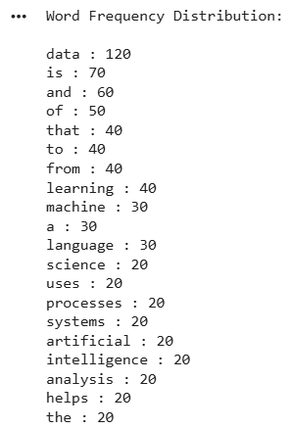
EXP.NO:14
Scenario: You are a data analyst working for a company that sells products online. You have been tasked with analyzing the sales data for the past month. The data is stored in a Pandas data frame.
Question: Develop a code in python to find the frequency distribution of the ages of the customers who have made a purchase in the past month.
CODE:
import pandas as pd
data = pd.read_csv("customer_ages.csv")
age_frequency = data["Customer_Age"].value_counts()
print(age_frequency)
OUTPUT:
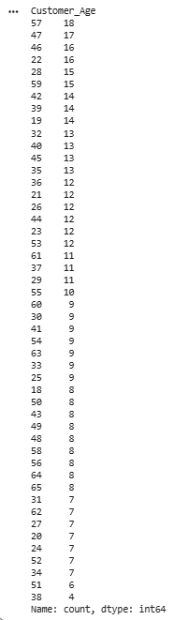
EXP.NO:15
Scenario: You are a data analyst working for a social media platform. As part of your analysis, you have a dataset containing user interaction data, including the number of likes received by each post. Your task is to develop a Python program that calculates the frequency distribution of likes among the posts.
Question: Develop a Python program to calculate the frequency distribution of likes among the posts?
CODE:
import pandas as pd
data = pd.read_csv("post_likes.csv")
likes_frequency = data["Post_Likes"].value_counts()
print(likes_frequency)

OUTPUT:
